Name:-Anuradha Desale

Practical:-8

Roll no:-14 Sub:- DV

import seaborn as sns

\

import numpy as np

# Generate random data np.random.seed(0)

x = np.random.rand(10) # Random x values y = np.random.rand(10) # Random y values

# Create a scatterplot

sns.set(style="whitegrid") # Optional: Set a style for the plot plt.figure(figsize=(8, 6)) # Optional: Set the figure size

# Create the scatterplot using Seaborn sns.scatterplot(x=x, y=y)

# Optional: Customize the plot further plt.title("Random Scatterplot") plt.xlabel("X-axis")

plt.ylabel("Y-axis")

# Show the plot plt.show()

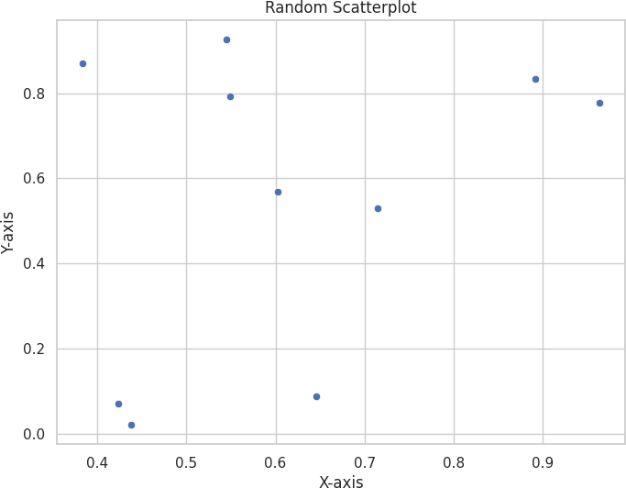

SWARM PLOT

import seaborn as sns

import matplotlib.pyplot as plt import random

# Create custom data with equal-length lists

categories = ["Category A"] * 3 + ["Category B"] * 3 + ["Category C"] * 3 + ["Category D"] * 3 values = [random.uniform(4, 30) for _ in range(12)] #3Generate 40 random values

# Create a swarm plot

sns.set(style="whitegrid") # Optional: Set a style for the plot plt.figure(figsize=(8, 6)) # Optional: Set the figure size

# Create the swarm plot using Seaborn sns.swarmplot(x=categories, y=values)

# Customize the plot (optional) plt.title("Custom Swarm Plot") plt.xlabel("Categories") plt.ylabel("Values")

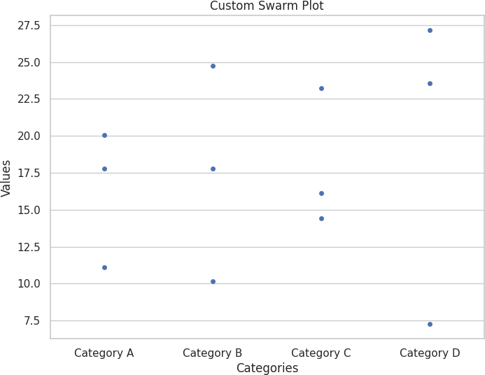# Show the plot plt.show()

pairplot

import seaborn as sns import pandas as pd

iris = sns.load_dataset("iris")

sns.pairplot(iris, hue="species") #The hue parameter in the pairplot() function is used to color the points in the plots based on a third variable.

C:\Users\HP\AppData\Local\Programs\Python\Python310\lib\site-packages\seaborn\axisgrid.py:118: UserWarning: The figure layout has changed to tight self._figure.tight_layout(*args, **kwargs)

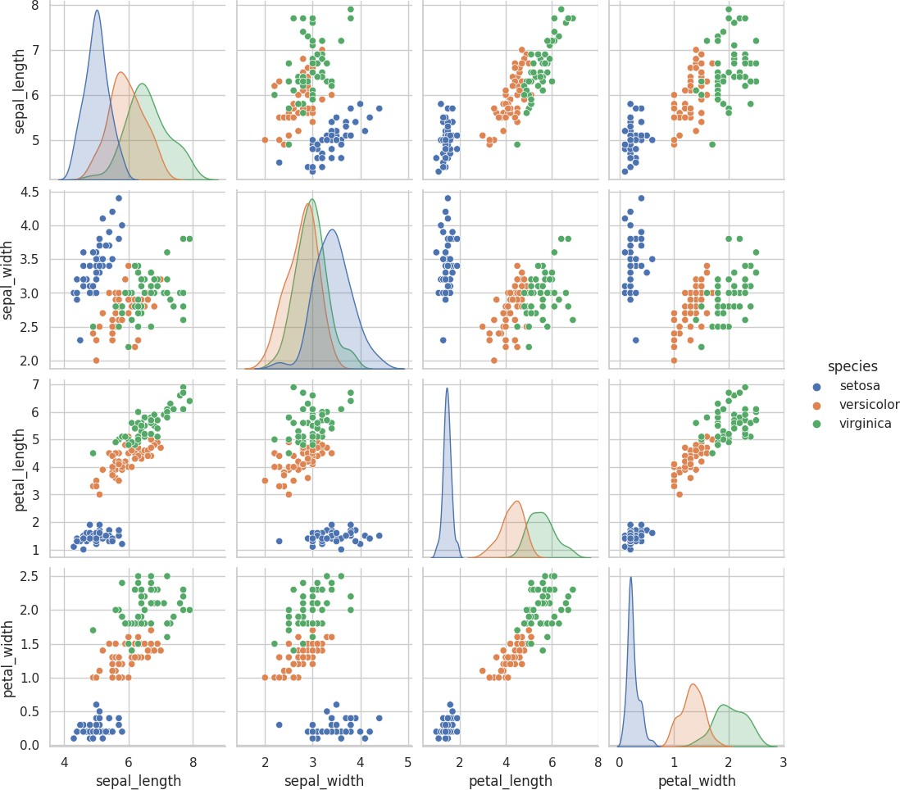

<seaborn.axisgrid.PairGrid at 0x2316d115ba0>

sns.pairplot(iris, kind="heatmap", hue="species")

C:\Users\HP\AppData\Local\Programs\Python\Python310\lib\site-packages\seaborn\axisgrid.py:118: UserWarning: The figure layout has changed to tight self._figure.tight_layout(*args, **kwargs)

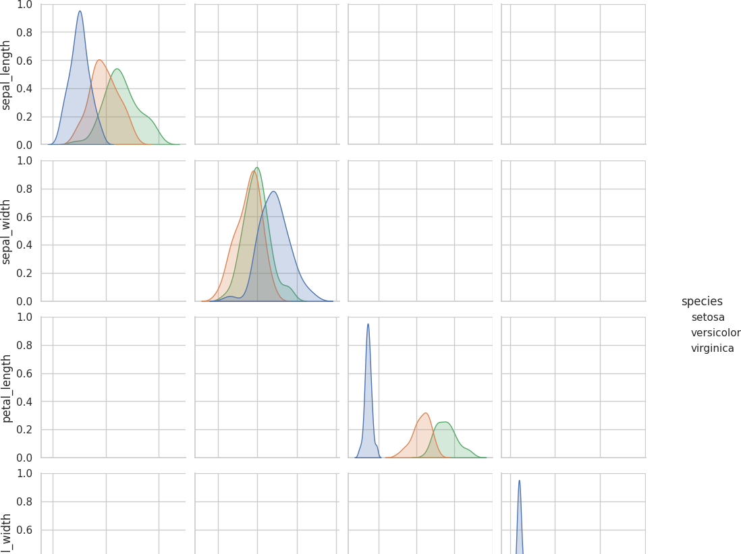

<seaborn.axisgrid.PairGrid at 0x2316d40a5c0>